SCHOOL OF COMPUTER SCIENCE AND ARTIFICIAL INTELLIGENCE |  |  |  |  | DEPARTMENT OF COMPUTER SCIENCE ENGINEERING
ProgramName:M. Tech |  |  |  | AssignmentType: Lab |  |  | AcademicYear:2025-2026
CourseCoordinatorName |  |  |  | Venkataramana Veeramsetty
CourseCode |  |  |  | CourseTitle |  | AI Assisted Problem Solving Using Python
Year/Sem |  |  | II/I | Regulation |  | R24
DateandDay  of Assignment |  |  | Week5 - Monday | Time(s)
Duration |  |  | 2 Hours | Applicableto  Batches
AssignmentNumber:10.1(Presentassignmentnumber)/24(Totalnumberofassignments)
 | Q.No. | Question |  |  |  |  |  | ExpectedTime  to complete
 | 1 | Lab 10 – Code Review and Quality: Using AI to Improve Code Quality and Readability  Lab Objectives  - Use AI for automated code review and quality enhancement.  - Identify and fix syntax, logical, performance, and security issues in Python code.  - Improve readability and maintainability through structured refactoring and comments.  - Apply prompt engineering for targeted improvements.  - Evaluate AI-generated suggestions against PEP 8 standards and software engineering best practices  Task Description #1 – Refactor Nested Conditionals  Task: Provide AI with the following nested conditional code and ask it to simplify and refactor for readability.  Python script.  def discount(price, category):  if category == "student":  if price > 1000:  return price * 0.9  else:  return price * 0.95  else:  if price > 2000:  return price * 0.85  else:  return price  Expected Output:  - Refactored code using cleaner logic, possibly a dictionary or separate helper functions.  Prompt: Improve the nested conditional code to simplify and refactor it for readability.  Code:  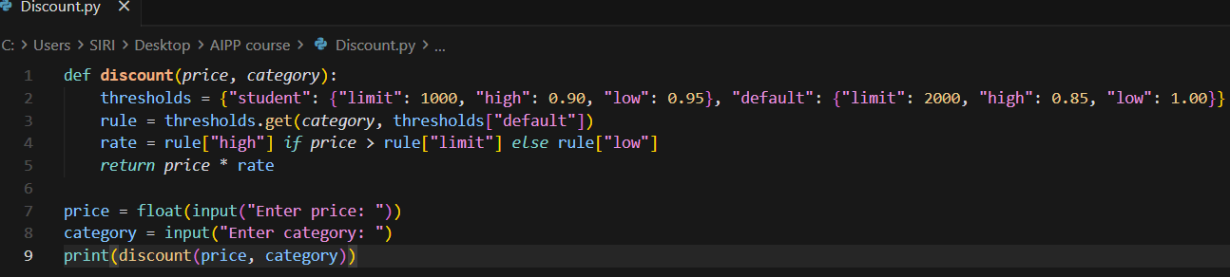  Code Explanation:  - A dictionary stores all discount rules for both student and default customers, including price limits and discount rates.  - The program selects the correct rule set based on the user’s category; if it doesn’t match, it uses the default rules.  - It checks whether the price crosses the rule’s limit to decide whether to apply the higher or lower discount.  - The final price is calculated by multiplying the original price with the selected discount rate.  - The user enters a price and category, and the program outputs the discounted amount based on these cleaner, organized rules.  Output:  Task Description #2 – Optimize Redundant Loops  Task: Give AI this messy loop and ask it to refactor and optimize.  Python script  def find_common(a, b):  res = []  for i in a:  for j in b:  if i == j:  res.append(i)  return res  Expected Output:  Cleaner version using Python sets (set(a) & set(b))  Prompt: Refactor this nested-loop Python function that finds common elements between two lists into a cleaner, optimized version using Python sets (set(a) & set(b)).  Code:  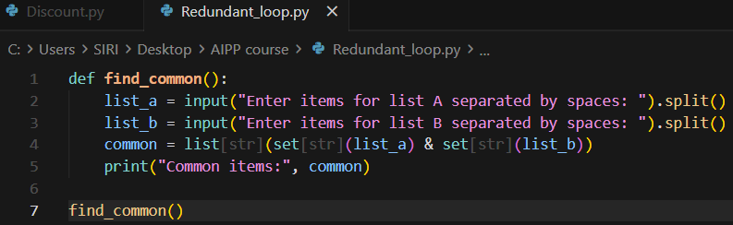Code Explanation:  - The program takes two space-separated lists as input from the user and converts them into Python lists.  - It uses set intersection to quickly find items that appear in both lists.  - It converts the result back to a list and prints the common elements.  Output:  Task Description #3 – Improve Class Design  Task: Provide this class with poor readability and ask AI to improve:  - Naming conventions  - Encapsulation  - Readability & maintainability  Python Script  class emp:  def __init__(self,n,s):  self.n=n  self.s=s  def inc(self,p):  self.s=self.s+(self.s*p/100)  def pr(self):  print("emp:",self.n,"salary:",self.s)  Expected Output:  - Employee class with meaningful methods (increase_salary, display_info), formatted output, and added docstrings.  Prompt:  Code:  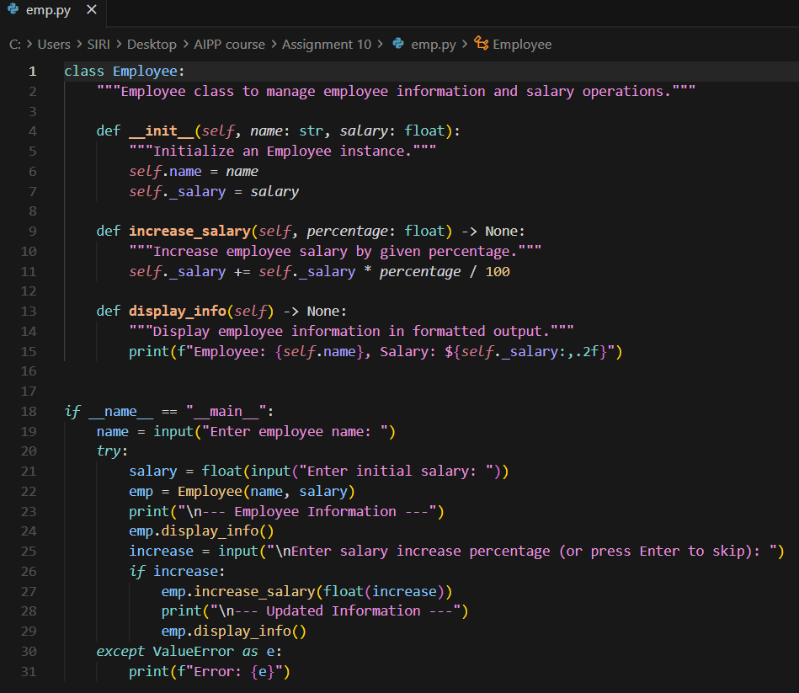  Code Explanation:  - The Employee class stores an employee’s name and salary and provides methods to manage salary updates.  - The constructor __init__ initializes each Employee object with a name and a starting salary.  - The increase_salary method increases the salary by a given percentage using a simple arithmetic formula.  - The display_info method prints the employee’s details in a clean, formatted way.  - In the __main__ block, the program takes user input for name, salary, and optional salary increase, then displays the updated information while handling invalid numeric input.  Output:  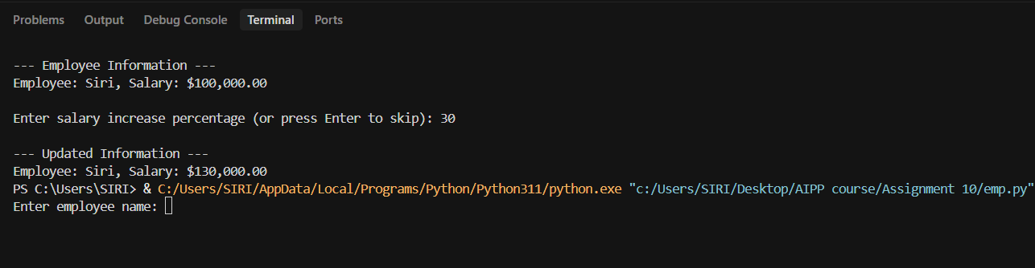  Task Description #4 – Modularize Long Function  Task: Give AI this long unstructured function and let it modularize into smaller helper functions.  Python Script  def process_scores(scores):  total = 0  for s in scores:  total += s  avg = total / len(scores)  highest = scores[0]  for s in scores:  if s > highest:  highest = s  lowest = scores[0]  for s in scores:  if s < lowest:  lowest = s  print("Average:", avg)  print("Highest:", highest)  print("Lowest:", lowest)  Expected Output:  - Split into functions: calculate_average, find_highest, find_lowest.  - Clean main process_scores() using helper functions.  Prompt: Refactor this long unstructured process_scores function by modularizing it into helper functions like calculate_average, find_highest, and find_lowest for cleaner, reusable code.  Code:  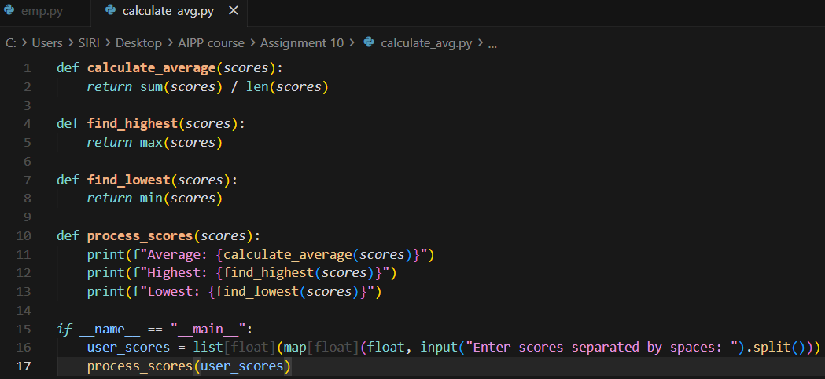  Code Explanation:  - The function calculate_average computes the average of all numbers in the score list using sum divided by length.  - The find_highest function returns the maximum value from the scores list.  - The find_lowest function returns the minimum value from the scores list.  - The process_scores function prints the average, highest, and lowest values by calling the helper functions.  - In the main block, the program takes space-separated numeric input from the user, converts them into floats, stores them in a list, and processes them.  Output:  Task Description #5 – Code Review on Error Handling  Task: Provide AI with this faulty code and ask it to improve error handling, naming, and readability.  Python Script  def div(a,b):  return a/b  print(div(10,0))  Expected Output:  - Function with proper error handling using try-except.  - Better naming (divide_numbers).  - AI-generated docstring explaining error handling.  Prompt: Review and improve this faulty Python code by adding proper error handling with try-except, renaming the function to divide_numbers, and providing a clear docstring that explains how errors—such as division by zero—are handled.  Code:  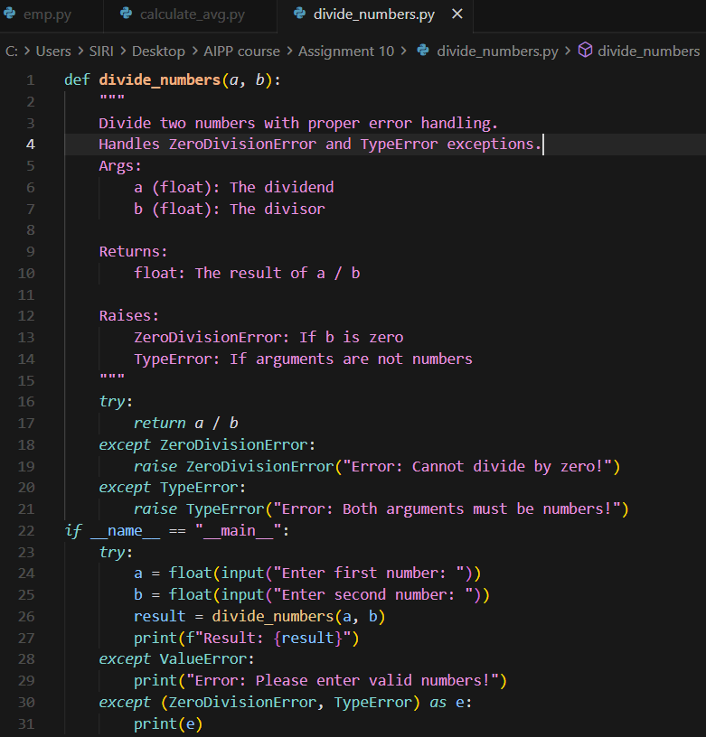  Code Explanation:  - The divide_numbers function divides two numbers and includes a docstring explaining its purpose, arguments, return value, and possible exceptions.  - Inside the function, a try block performs the division while catching ZeroDivisionError and TypeError to provide custom error messages.  - If the divisor is zero, a meaningful ZeroDivisionError is raised; if the inputs are not numeric, a TypeError is raised.  - In the __main__ block, the program takes two numbers from the user and attempts to divide them using the function.  - The outer try-except handles invalid number inputs (ValueError) and prints the specific error message for division or type-related problems.  Output:  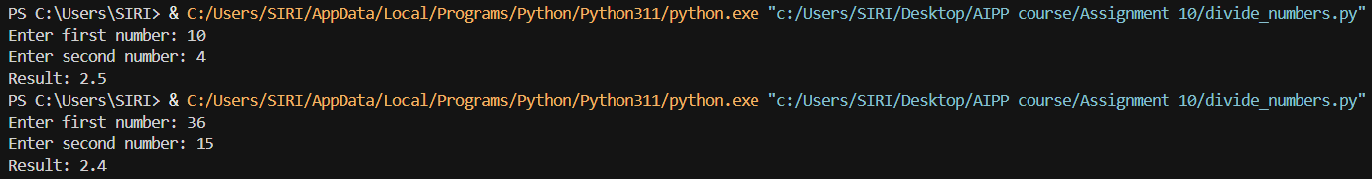  Task Description #6 – Complexity Reduction  Task: Use AI to simplify overly complex logic.  Sample Input Code:  def grade(score):  if score >= 90:  return "A"  else:  if score >= 80:  return "B"  else:  if score >= 70:  return "C"  else:  if score >= 60:  return "D"  else:  return "F"  Expected Output:  - Cleaner logic using elif or dictionary mapping.  Prompt: Refactor this overly nested grading function to reduce complexity by replacing deep nested if statements with cleaner logic using elif or a dictionary-based mapping.  Code:  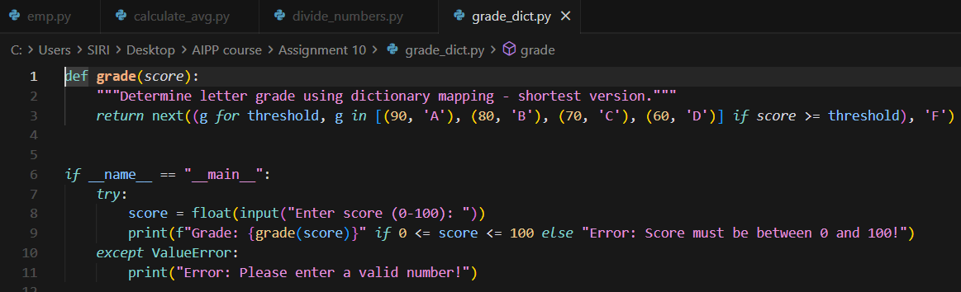  Code Explanation:  - The grade function uses a compact dictionary-style threshold list and a generator expression to determine the correct letter grade.  - It checks each threshold in descending order and returns the first matching grade for which the score is high enough.  - If no thresholds match, it defaults to 'F' using the final argument of next().  - In the main block, the program asks the user for a score and ensures it lies between 0 and 100 before displaying the grade.  - If the user enters invalid or non-numeric input, a ValueError is caught and an appropriate error message is displayed.  Output: |  |  |  |  |  | Week5 - Monday

